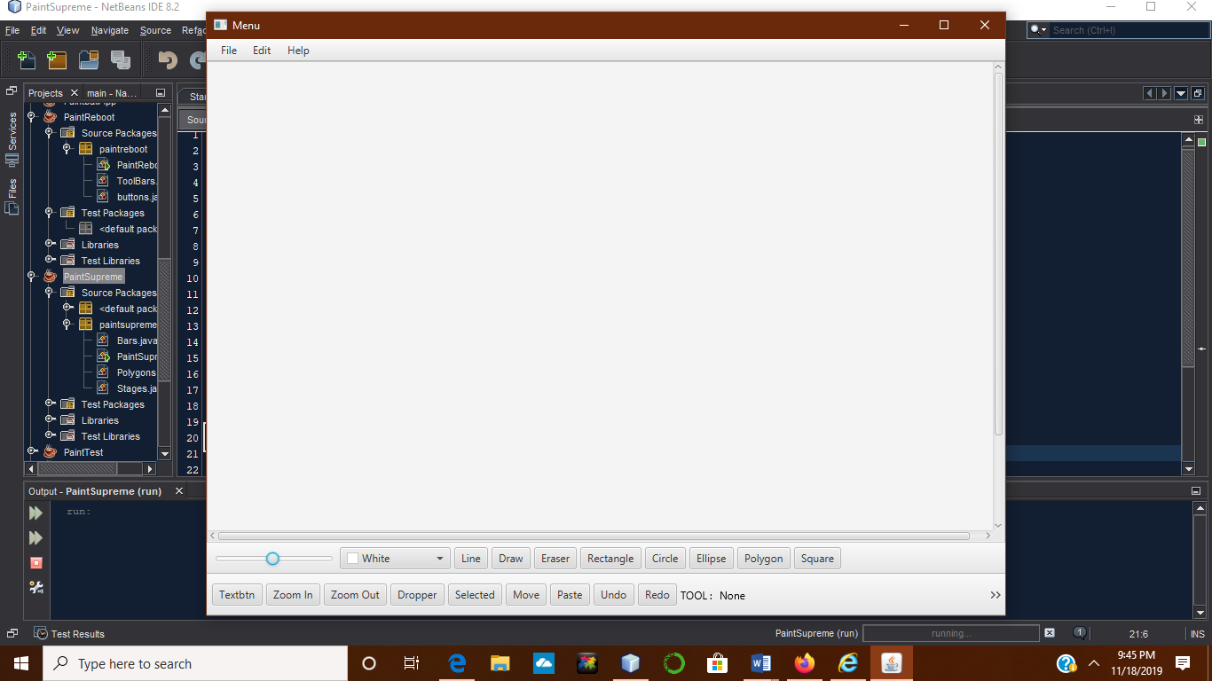

This is the opening stage of PaintSupreme…the TOOL: None is showing that no tool has been selected yet.

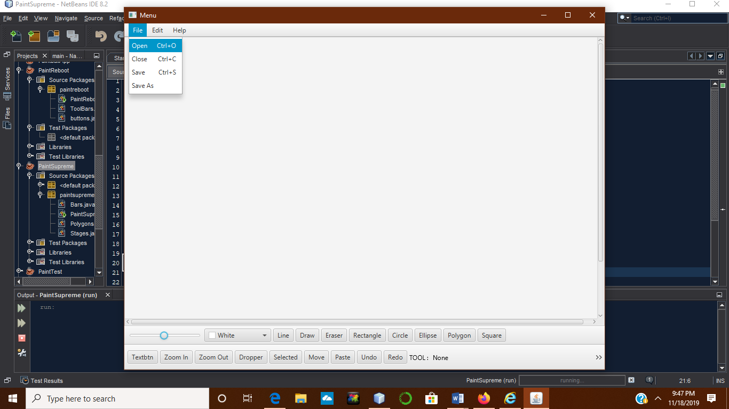

You can open pictures to be manipulated by various tools.

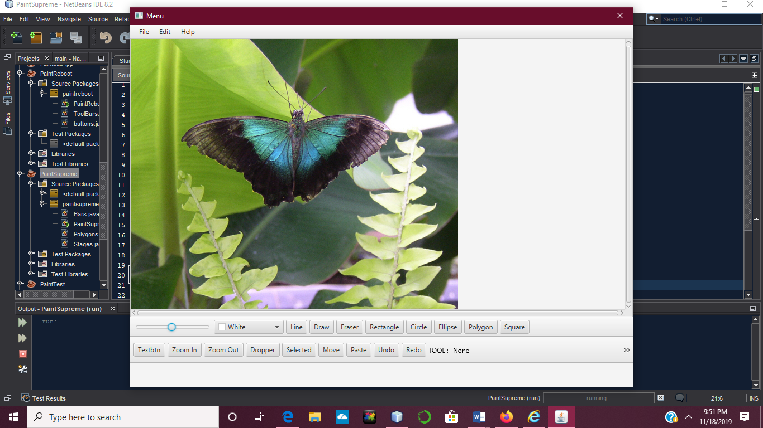

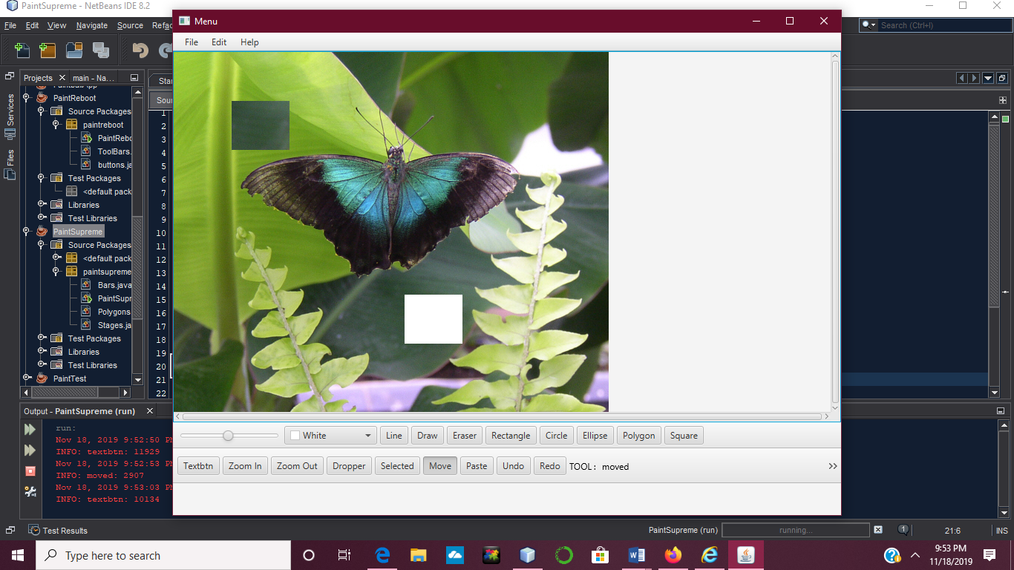

Selection tool, takes whatever portion of the picture you select and the moved button moves that selected portion to another place on the canvas and leaves a void in its place.

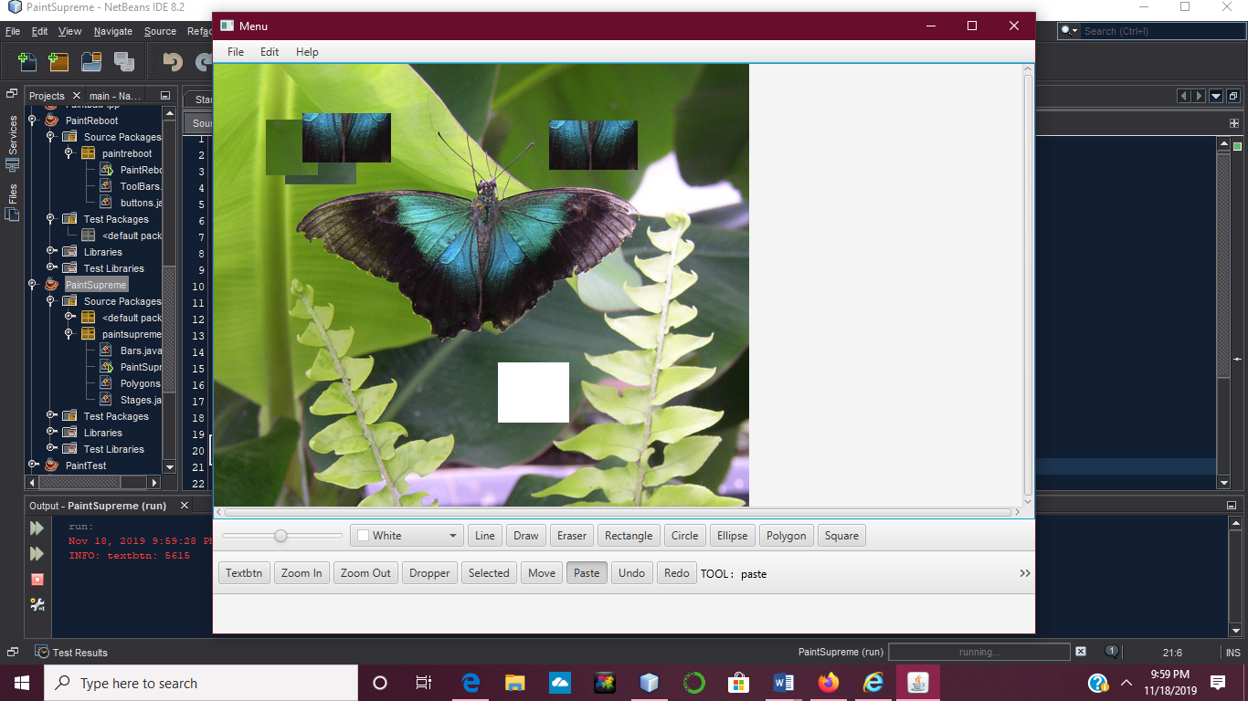

The paste button will allow you to take a selection and paste it but it won’t leave a void in that place that it was taken from.

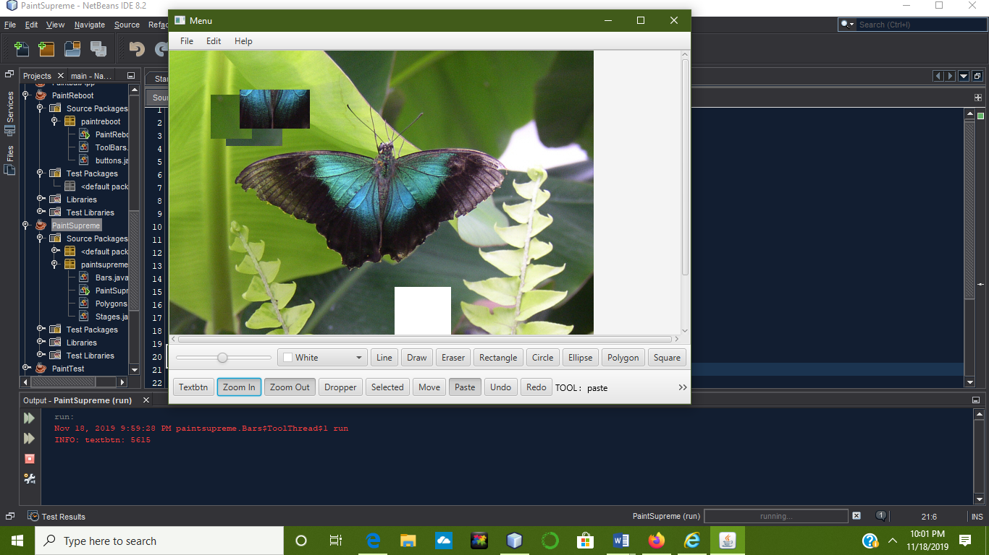

Zoom in

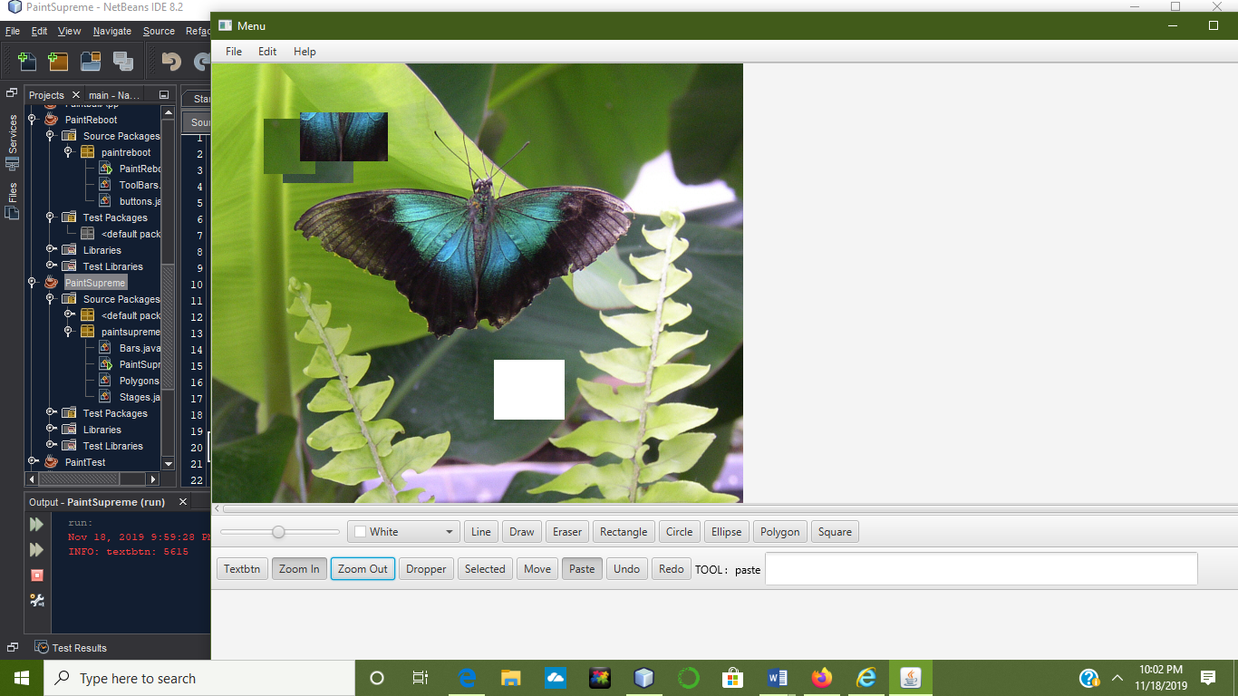

Zoom out

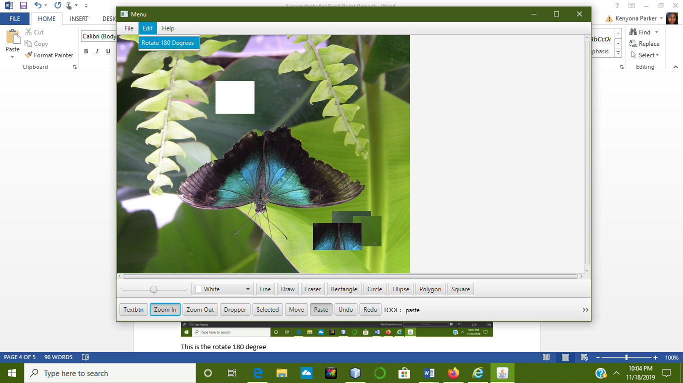

This is the rotate 180 degree

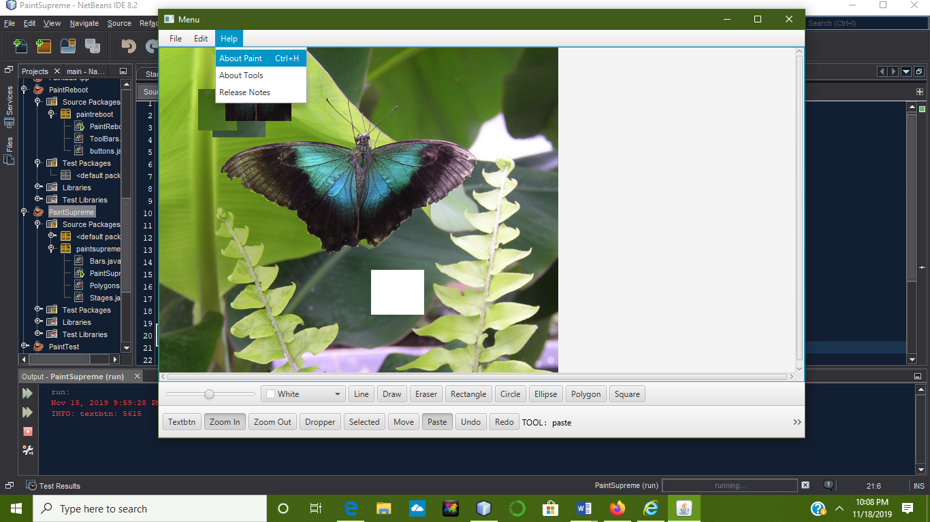

This is the Help tab, it has about paint, about tools and release notes.

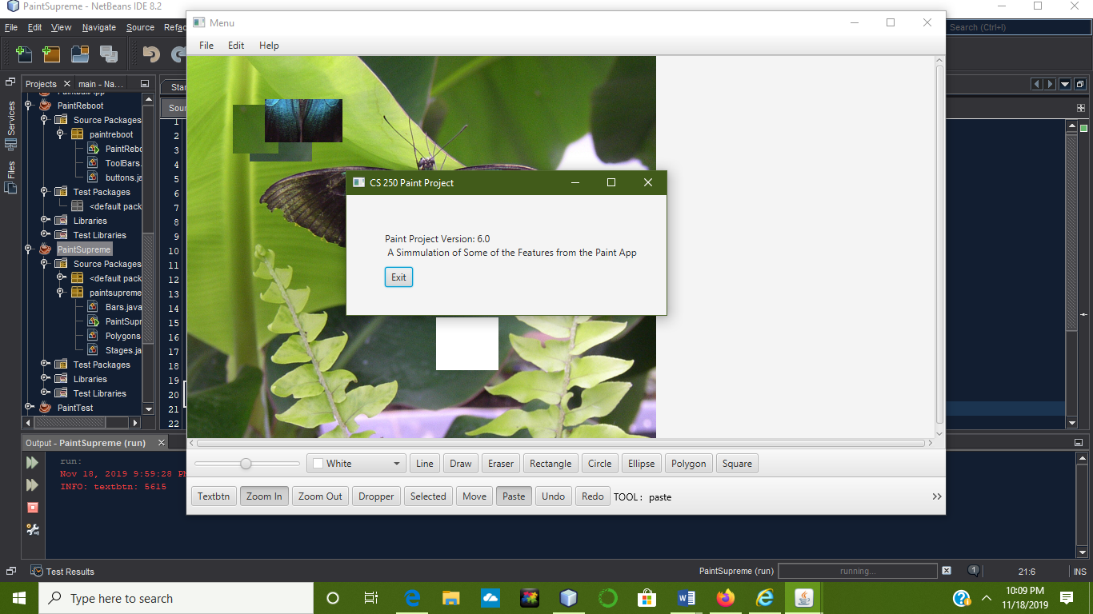

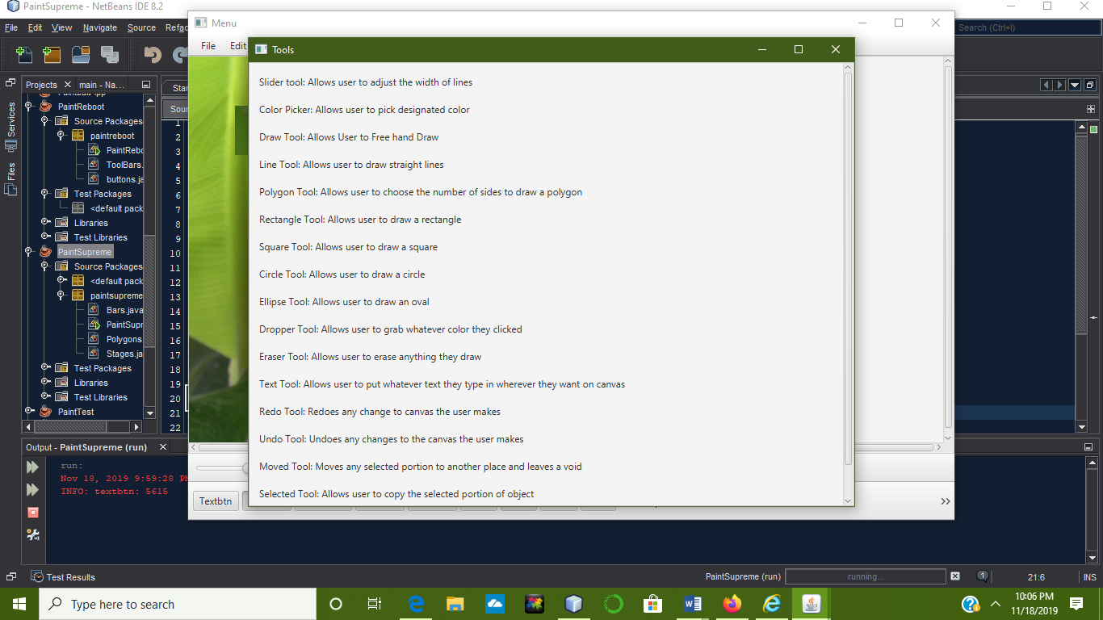

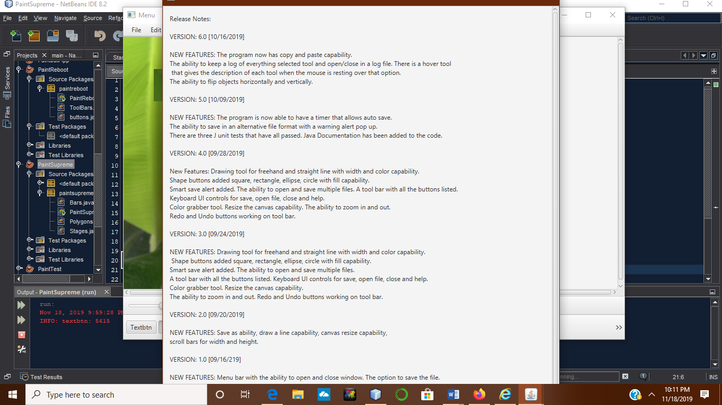

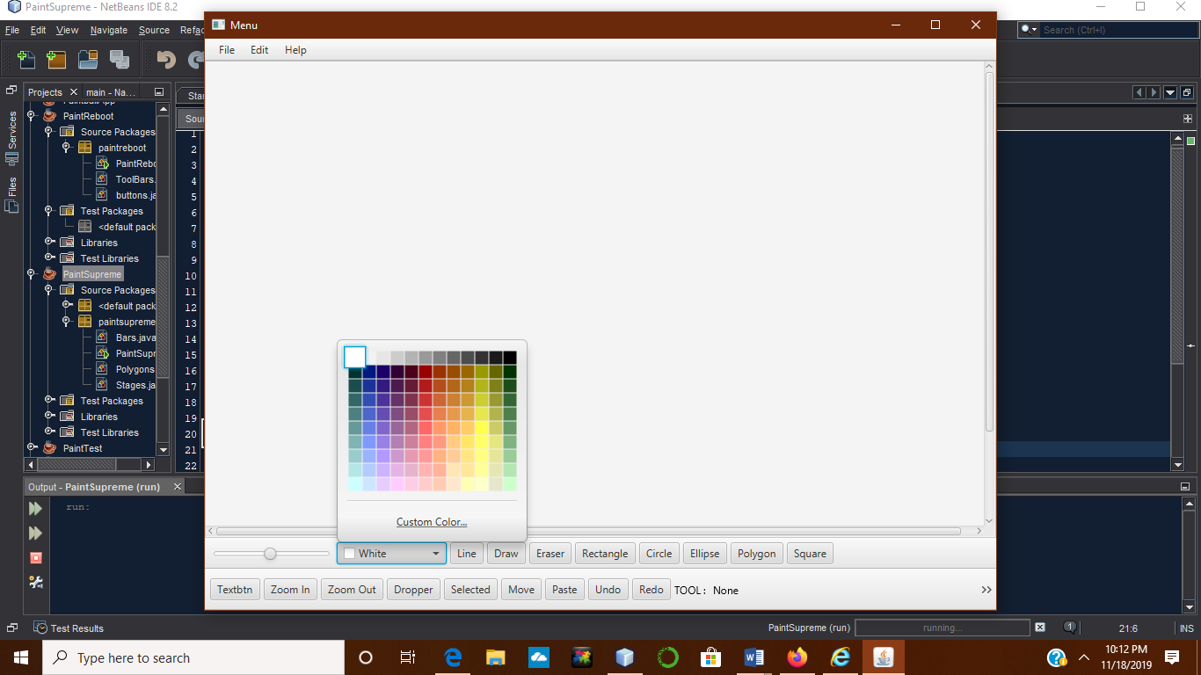-

Color picker tool with a slider to adjust the width of the line drawn.

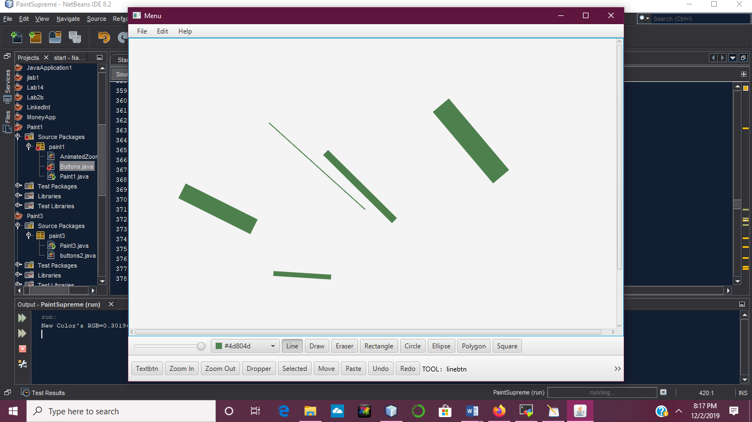

These are various size lines drawn with the slider options.

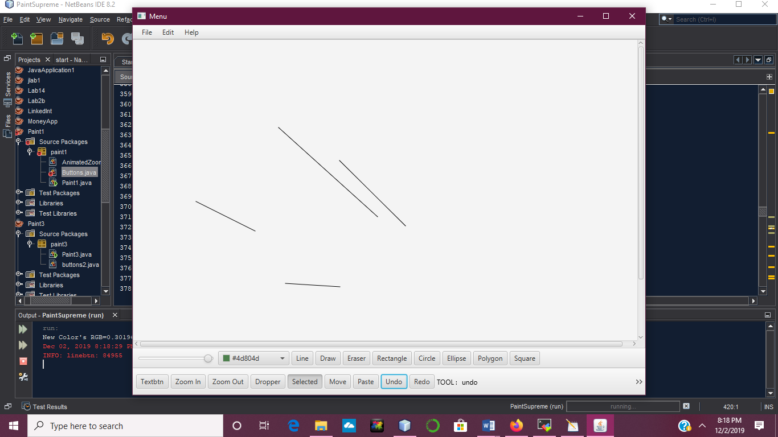

Undo button selected to erase the lines drawn.

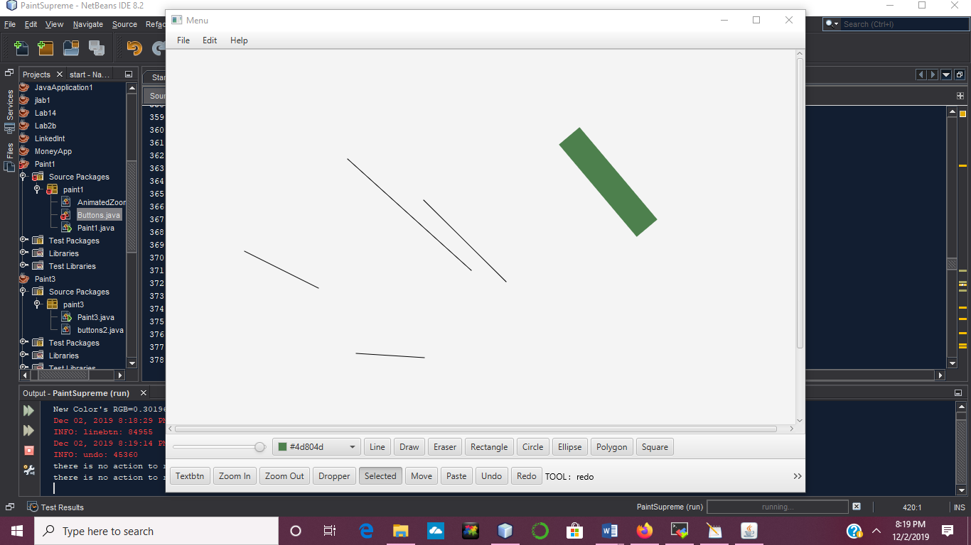

Redo button brought back the line that was previously erased.

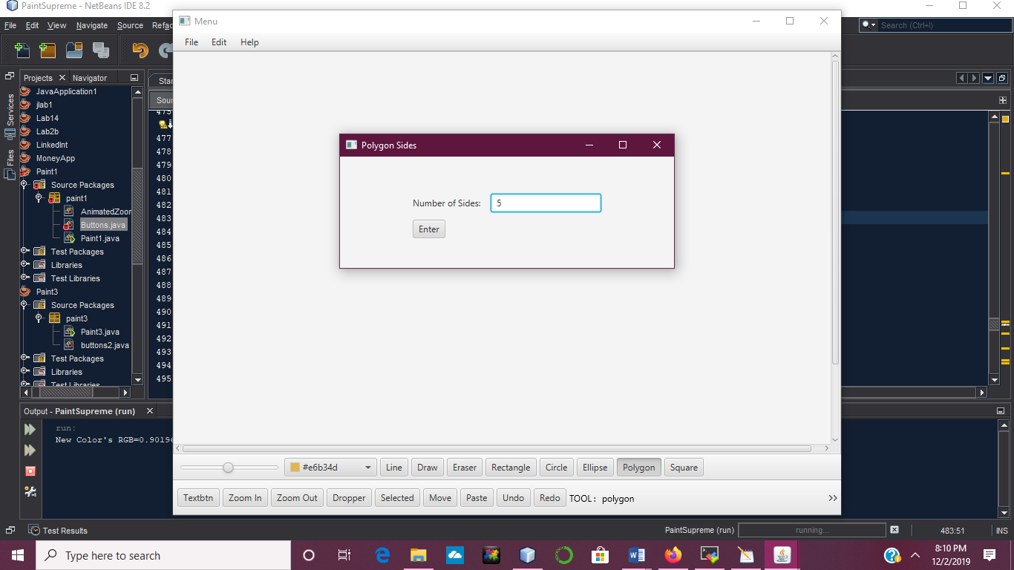

Polygon shape selected with number of sides pop up question.

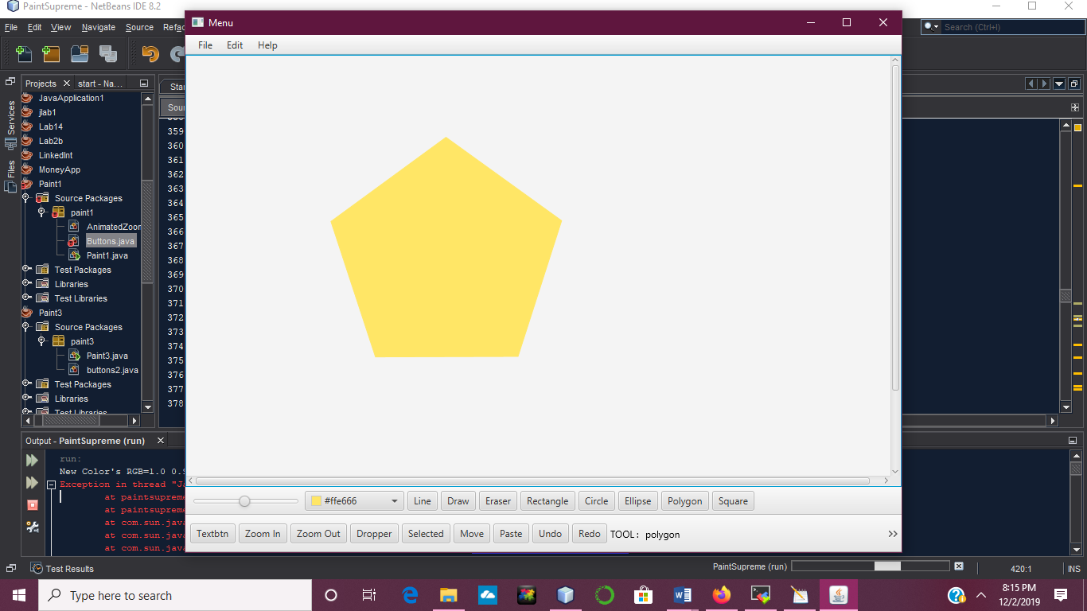

Polygon is drawn with 5 sides.

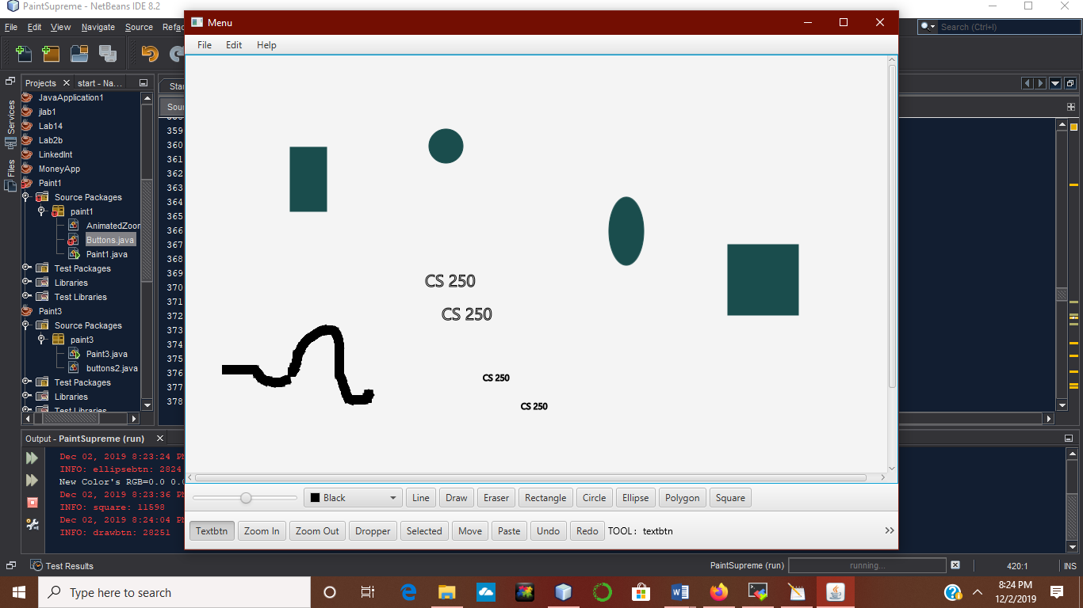

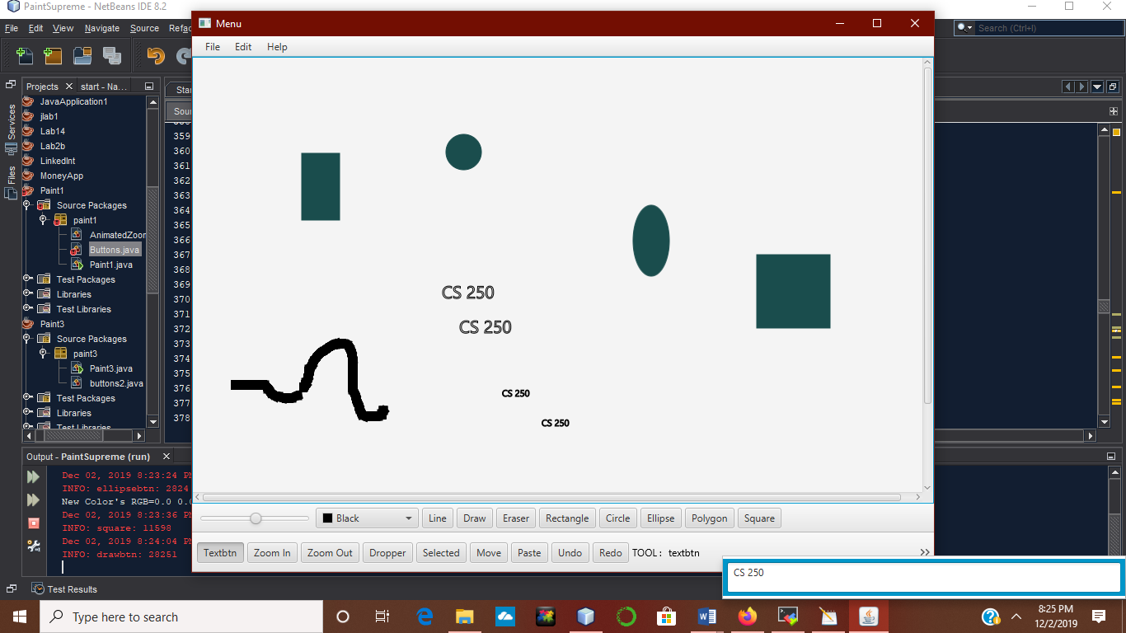

This is all of the shapes that can be drawn including the text button feature.

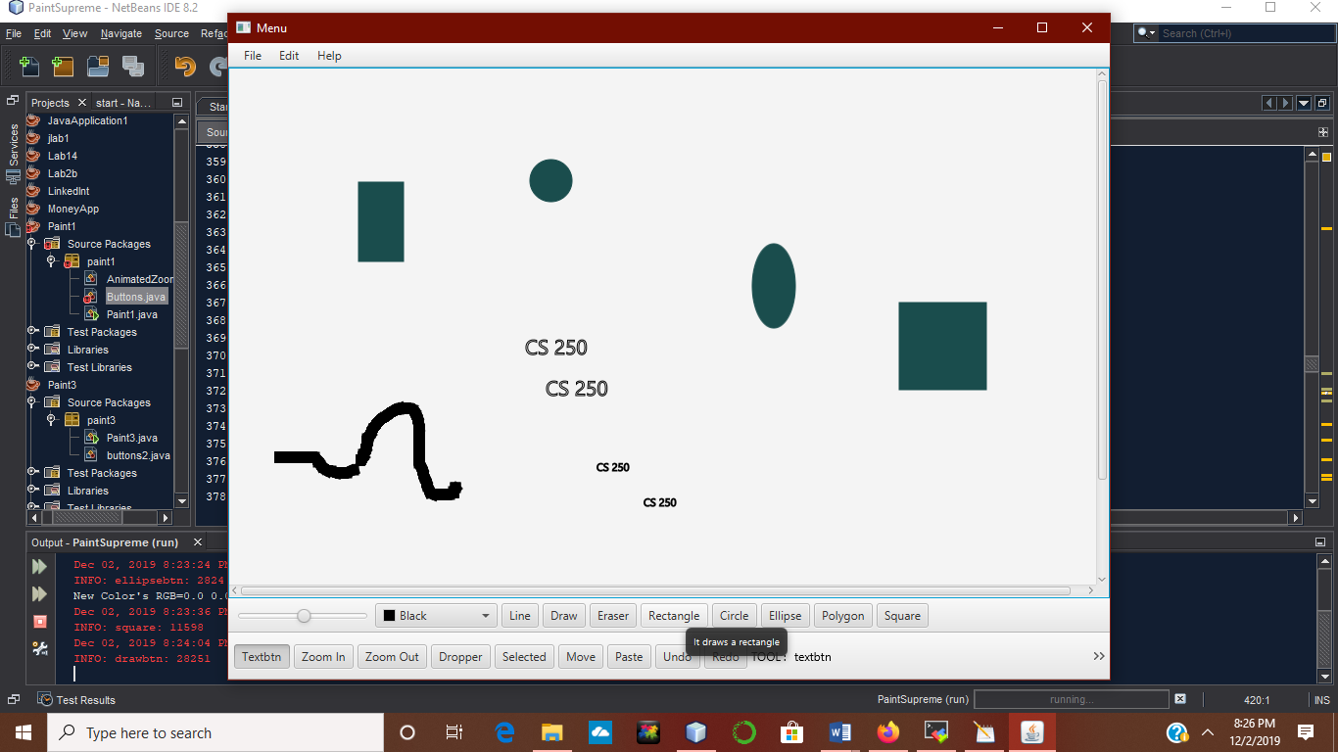

The hover tool tip shows a description of each tool when the mouse hovering over that button.

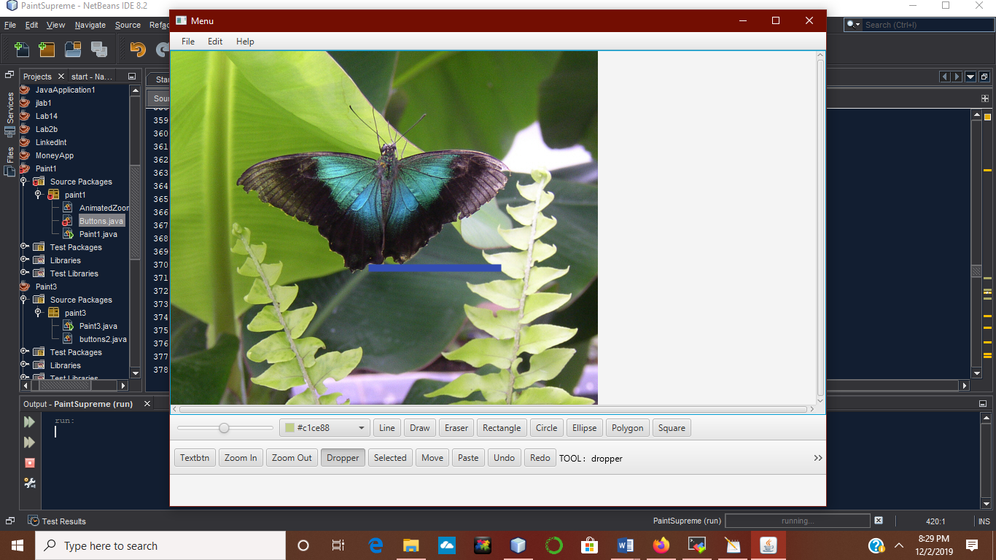

The dropper tool will change to whatever color you select in a picture.

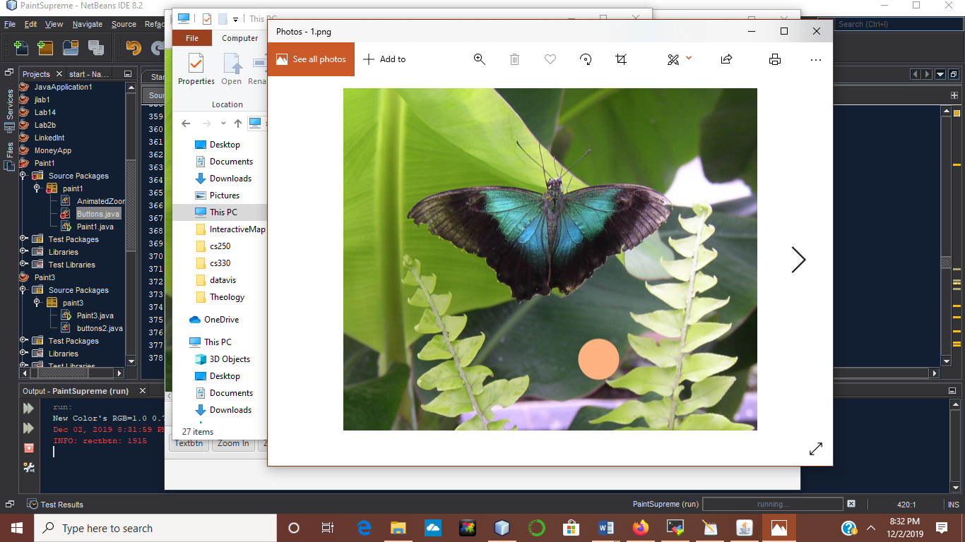

The auto save feature will save any changes made to the picture without having to select save as.